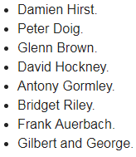

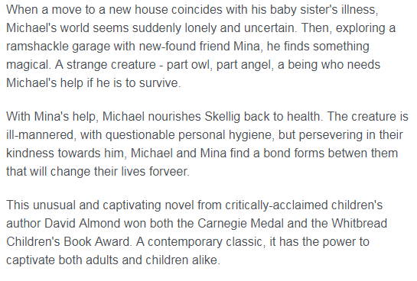

In this Unit pupils will study how our Earth adapts and changes over time. We will be examining theories first explained by Charles Darwin and explore how modern thinking has added to the evidence about our changing Earth.

**Planet Earth.**

**Rinsey Class. Summer 2018.**

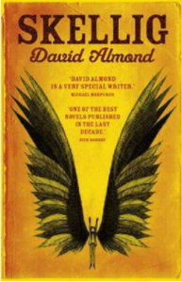

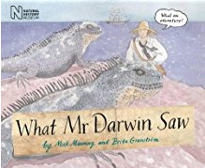

In this term we will study Charles Darwin and his contribution to modern scientific thinking. We will also be enjoying a trip to our capital city, London, and studying influential architects from around the city and the world.