Homework Spring 1st Half Term
We have continued to create optional homework tasks that can be completed to achieve certificates. There are 8 tasks; 4 relating to the class topic and 4 relating to the school’s Personal Moral Spiritual topic for the half term. They are optional as we are aware that many children take part in a large range of extra-curricular activities after school. Class teachers however, may set English or maths homework that is expected to be completed – if this is the case you will be informed on a class by class basis. Remember, if you only do one thing reading with or to your child is likely to have the most significant impact on their progress in school. Also remember, that the school is subscribed to MATHLETICS; an online maths support website where children can play fun games to practise key maths strategies and rehearse important facts – including times tables for which we will still be awarding Karate style wrist bands. Certificates are also given out each week for children that score over 1000 points on Mathletics each week and the child with the highest score in each class gets to choose something from a prize box on Friday.

Reading: Remember reading is the most important homework you can do; try and read every night even if it is just for 10 minutes. Sometimes it is also nice to have stories read to you (these count in your termly total). This term every child from Year 2 upwards will be given a Reading Passport to encourage them to read after the more structured progression in Foundation and Year 1. Every time they complete a book they can collect 1 – 3 stamps (dependent on book’s length) in their passport. Each completed page is entered into a draw at the end of term and the first 5 drawn out get to travel to Truro to buy a book of their choice from Waterstones funded by the school.
PSHE:  Be The Best You  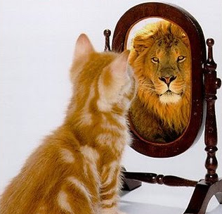 | BE KIND  At Gwinear School we try to make sure that everyone feels included.  Design a game to play at playtime that could include anyone and everyone who wants to play.  Your game could  - use any of the equipment  - might include turn – taking  - should be active  Write or draw your ideas and we promise to give it a try at playtime! | BE A SUPERHERO  What are you really good at? If you were a superhero, what would your superpower be? Everyone has strengths and weaknesses – even Superheroes!  Draw or make your superhero self – what would your costume look like? What would your symbol and name be?  What would your superpower be? You could be ‘Superspeller’? Or maybe ‘Mathsman’? You might be able to draw your way out of any situation…. ?  Your drawings and models will be displayed around the school so our visitors know what Superheroes we have in Gwinear school! | BE IN CONTROL OF MY FEELINGS  Sometimes it’s hard to calm down when we are angry or upset but this is an important skill to master!  How do you manage your feelings?  Create a poster showing three (or more!) steps to calming down when you are upset or angry. What might you feel/ look like before and after?  The clearest posters will be displayed on our PSHE wall in the hall, to help others try your techniques. | BE HEALTHY – MIND AND BODY  Having a healthy diet is essential for your body and mind. It keeps you functioning properly and able to learn and play to the best of your ability.  Have a look at this website for loads of healthy meal ideas:  www.bbc.com/food/collections/healthy_recipes_for_kids  Try making a new healthy recipe- maybe something you have never tried before?  Share the recipe with us! Take photos or write the recipe – did you enjoy it? Will you be trying it again?  Try keeping a food diary for a week - which were your best food choices? Which could you change for something healthier?
 | Comment | Comment | Comment | Comment
Our Topic  To Infinity and Beyond!  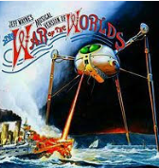 | 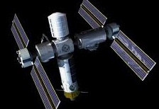  Design a space station – one that can be used for scientific experiments and for comfortable living. What must you include? What would be your chosen comforts? What do you think would be included in the future? | Make a space craft from any materials you like – but it must fit onto an A4 piece of card/mount.  Think about things you have around the house that look a bit technical, and use those (with permission, of course!) Make it as inventive as you like.  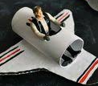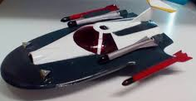 | Find as many songs as you can that are to do with space – they can be classical, pop, country…  Make a presentation of the bits you think are the most effective at showing what you think about space as a whole – whether it is fun, scientific, emotional or puzzling!  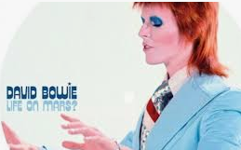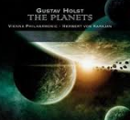 | Do you think we can ever live on another planet, and, if so, which one would you choose?  You might choose Mars - 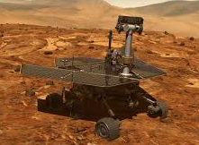  or another planet – what would you choose and why?  Present your opinion clearly so we can debate it in class.
 | Comment | Comment | Comment | Comment

