Homework Spring 2nd Half Term
After with previous years we have chosen to keep with the format used for homework and hope that it offers you opportunities to support core academic learning but also to be creative and have fun with learning. The tasks set are optional but it would be good to try at least one PSHE and Topic homework whilst reading remains the single most important thing you can do at home to support your child in school. The school now subscribes to Seesaw and sometimes teachers may suggest that you post your efforts for topic and Personal Moral Spiritual tasks on your journal otherwise bring them into school. The school continues to use the internet based maths resource, Mathletics, and has now also subscribes to Times Table Rockstars. You should have logins for both resources (obtainable from Mrs B or your class teacher). Occasionally teachers may choose to set tasks on Mathletics but if they do not you can practise maths of your choice and Times Table Rockstars is excellent for learning those all-important facts. Mathletics certificates and times table bands will be awarded in Friday Celebration assemblies. Teachers will also monitor children’s reading records and two children from each class will be selected at the end of term for a trip to Waterstones in Truro to choose a book that the school will pay for. We hope you have fun supporting learning at home and did I mention that reading is very important.

Reading. Remember reading is probably the most important homework you can do. Try and read every night even if it is just for 10 minutes. Sometimes it is also nice to have stories read to you. It is not the number of books you read that matters as some of you will be reading much longer books than others. The important things are that you understand what you are reading and enjoy what you are reading. If this is not the case speak to your teacher because they will do all they can to help you read together at home. You all have a reading record to track your reading so you don’t need to write anything here and teachers will now be choosing 2 children from each class every half term for the treat to head to Waterstones in Truro to choose a book the school will pay for.
Personal Moral Spiritual  Journeys  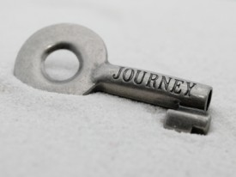 | 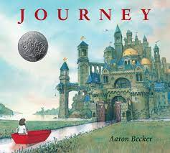  A Journey Story  In our first assembly we looked at the book Journey by Aaron Becker. It is a beautiful book and I would advise any parent of young children to get a copy if you haven’t already. There are some tasks linked to the story that can be found using this link: aaronbecker_journey_trilogy_activity_kit.pdf (storybreathing.com)  Either complete some of the tasks or try writing your own Journey story only using pictures!! | 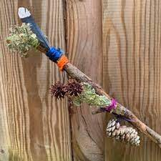  Take a trip.  The obvious journey homework is to go on one!! It can be as adventurous or as gentle as you like. It could also be familiar or one you have never done before – I always see something new on my favourite walks but I love a new exploration. By foot, bike, boat, horse! Your choice. Keep a record of your journey anyway you like; a diary, photographs or a collection of mementos you find on the way maybe made into a ‘Journey Stick’ (this link shows how to make one How to make a Journey Stick - YouTube. However, you record it be sure to share with your class. | Making choices.  Every time you make a choice in life it has a consequence. Other things happen in life that change us but over which we have no control. Make a fortune teller to show some of the things that might happen in life. This website shows you how to make them although not about life’s choices: How to Make a Paper Fortune Teller – Scout Life magazine. Alternatively, you could write a choosing story where the reader has to decide what to do – ask your teacher how to do this if you want to have a go as it is challenging. | 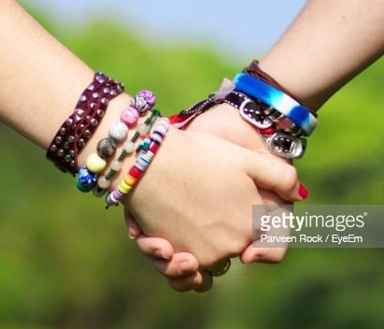  Travelling together:  Life is a journey that is difficult to travel alone. What makes someone a good friend to travel with? All friends like to feel valued so make something for a friend; it could be a bracelet (this link shows how to make a tricky one how to make a friendship bracelet - Google Search) or something else you know they would like to remind them of how close you are. It means so much more if you make it though.
 | Comment | Comment | Comment | Comment
Our Topic | In Science we are learning about rocks and their uses. Go for a walk in your local area and photograph different rocks that have been used for different purposes. For example, a bridge may be built from granite. Write down what type of rock has been used for different purposes and what properties that rock has that makes it suitable for that purpose (for instance strong, weatherproof.) | We are travelling further back in time to the Triassic period (the time of the Dinosaurs!) Choose your favourite dinosaur and research it. Create an information booklet or PowerPoint about your dinosaur. You could even build a model of your dinosaur. | 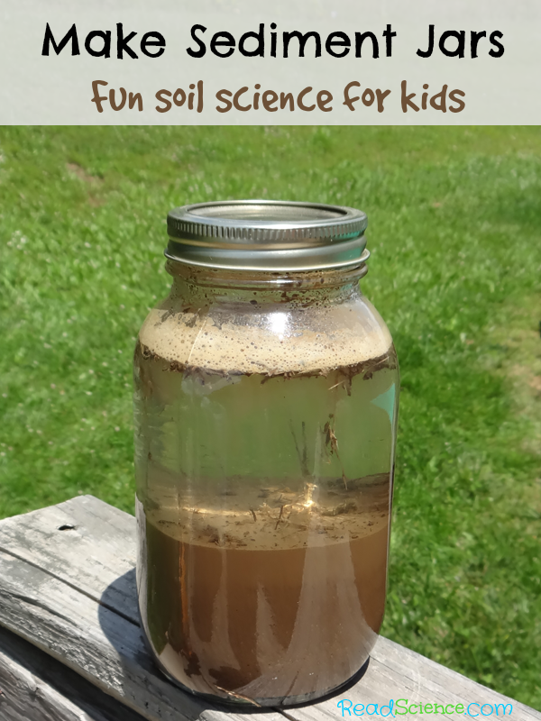  Science - Learn all about the layers of the earth, why some rocks have layers, and how sediment forms and is moved about with this fun sediment jar science investigation! Add various natural materials to your glass jar: sand, leaves, compost, gravel etc. fill your jar with water and leave it to settle. After an hour, look carefully at the layers which have formed. Can you write about the different layers of sediment? | In literacy we are writing newspaper reports. Choose an event and pretend to be a newspaper reporter. Create your own newspaper article and report about what happened. You could write about a national event like the Queen’s platinum Jubilee, a sporting event or something happening in our local area.
 | Comment | Comment | Comment | Comment
Mathletics | The school has decided to continue to subscribe to mathleticsand we also now have Times Table Rockstars.  Certificates awarded on Mathletics or Rockstars this term and Karate Bands achieved:
 | Comment

