TOPIC TITLE:  To Infinity and Beyond! | Launch  Story map of War of the Worlds  Role play in drama environment | Class Book  Story map of ‘War of the Worlds’  Role play in drama environment | End Authentic Outcome  A publication entitled ‘To Infinity and Beyond!’ published by the pupils
What will the classroom look like?  Tripods will be invading the drama environment  Aliens will be in the ceiling space  The planets will be as a backdrop  A story map will support the theme and HG Wells book  There will be a ‘pod’ in which individual astronauts will make a log of their voyage | How will you make it WOW?  Make a drama environment and log - pod  Compose music to go with story telling  Use original footage and newspaper reports (terrified audience thinking the story was real)  Finding out about how some science fiction predictions have come true  Use visual resources from films old and new  use art work from original and modern adaptations  use radio play  read and compare graphic novels  create landscapes using clay – link to Geography  History - investigate the history of space travel including recent (Tim Peake)  Spaceport Cornwall | What trips visits could support it?  CSIA space – planetarium  Tolcarn observatory  Caradon observatory  Goonhilly | Genres of writing to be covered?  Narrative – Sci Fi  Direct speech  Poetry  Persuasive  Biography  Graphic novels  Diary/log
 |  | Use of outdoor class  Beach ,woods – inspiration for writing  Rock formation – rocks moved and folded to make the different layers, patterns and composition. | Innovative use of ICT  Stargazing App reports  Lunar cycle App and modelling  Writing log and using internet images for stimulus  Hubble telescope pictures  On line information on Tim Peake  Cornwall space port webinars  Making the graphic images come alive  Photograph pupils as graphic shots and add captions
Class Rinsey year 5 and 6 Medium term Plan Spring 2023

MINI OUTCOME
Astronaut logs of imagined space flights

MINI OUTCOME
Biography of a fictional character in the HG Wells

MINI OUTCOME
Graphic novel pages

MINI OUTCOME
Story role play – hot seat, freeze frame

MINI OUTCOME
Persuasive writing – keep the alien alive!

MINI OUTCOME
History of space flight timeline
MINI OUTCOME
textiles art – tie dye alien disguises
MINI OUTCOME
Space composition – music influenced by Holst
Publication
War of the Worlds

Science
Facts about the solar system
ICT star app
Elements on Earth – what do we really need?
Chemical reactions
electricity

PSHE/SMSC

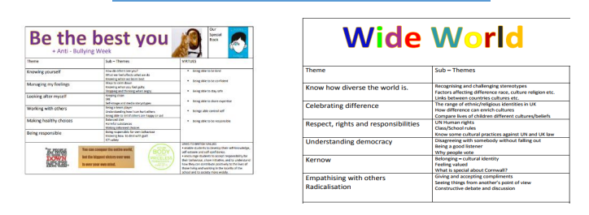
History/Geography
History of space travel
HG Wells and the scientific times in which he lived
Contour lines
Volcanoes
Tectonic plates

Music
Jeff Wayne
Holst – ostinato (Mars)
Pentatonic scales
PE/Dance

Art
Pop art – Lichtenstien space artists
1950 advertising
Clay modelling – lunar/Mars/planet landscapes
Illustration and graphic novels

Maths
Big numbers
What’s the biggest number?
What is infinity?
Magnification / ratio

