Rinsey Homework Autumn 2nd Half Term
After with previous years we have chosen to keep with the format used for homework and hope that it offers you opportunities to support core academic learning but also to be creative and have fun with learning. The tasks set are optional but it would be good to try at least one PSHE and Topic homework whilst reading remains the single most important thing you can do at home to support your child in school. The school now subscribes to Seesaw and sometimes teachers may suggest that you post your efforts for topic and Personal Moral Spiritual tasks on your journal otherwise bring them into school. The school continues to use the internet based maths resource, Mathletics, and has now also subscribes to Times Table Rockstars. You should have logins for both resources (obtainable from Mrs B or your class teacher). Occasionally teachers may choose to set tasks on Mathletics but if they do not you can practise maths of your choice and Times Table Rockstars is excellent for learning those all-important facts. Mathletics certificates and times table bands will be awarded in Friday Celebration assemblies. Teachers will also monitor children’s reading records and two children from each class will be selected at the end of term for a trip to Waterstones in Truro to choose a book that the school will pay for. We hope you have fun supporting learning at home and did I mention that reading is very important.

Reading. Remember reading is probably the most important homework you can do. Try and read every night even if it is just for 10 minutes. Sometimes it is also nice to have stories read to you. It is not the number of books you read that matters as some of you will be reading much longer books than others. The important things are that you understand what you are reading and enjoy what you are reading. If this is not the case speak to your teacher because they will do all they can to help you read together at home. You all have a reading record to track your reading so you don’t need to write anything here and teachers will now be choosing 2 children from each class every half term for the treat to head to Waterstones in Truro to choose a book the school will pay for.
Personal Moral Spiritual  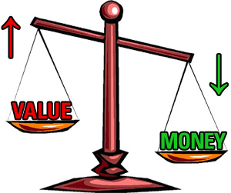  What’s  It Worth? | Money Money Money?  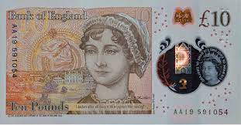  We have a new King and soon there will be new money with his head on it rather than Queen Elizabeth II. So, one side of the new bank notes is already decided but who should be on the other side? It should be a very important British person. A list of people that have featured up to now can be found here: Historical British figures featured on banknotes (1970-2017) (familymoney.co.uk). Who do you think should be added? Choose a person and design your note (both sides if you wish). You might want to try and change what usually happens because there have been very few women featured (Eliizabeth Fry, Florence Nightingale and Jane Austin) and no people of colour or living people. | Worth more than Gold  In the book that we read with this Arthur is sent by his master, Spinifex, to find as much gold as possible. On his travels he finds many things that are not gold but that he thinks are just as valuable – maybe more. Make a collage of things that are worth more than gold or like I did in our first assembly this term come up with a group of objects that represent something valuable to you e.g. my trainers represented my health and my watch represented the free time in the week that I get to enjoy. | Giving at Christmas/Solstice  We are coming close to the time of year when gifts are often given with people celebrating Christmas and/or the days beginning to lengthen after the solstice on the 21st. As we all know there are many people who are not as fortunate as us and many charities such as the Salvation Army allow you to make or buy a gift for someone in a difficult situation. Look at some different websites, choose a charity that you want to support and help make someone’s Christmas special. | Creative Enterprise  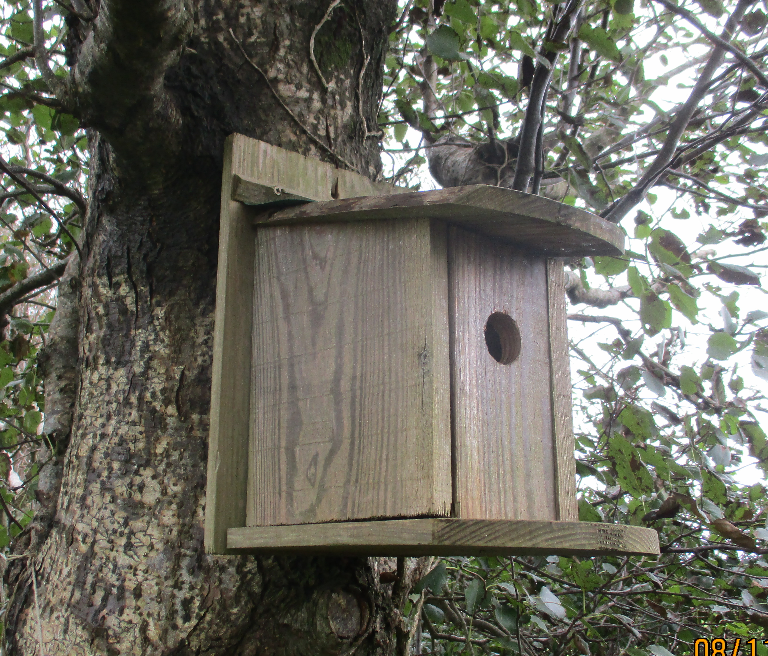  Each of the four classes will be making something to sell at the Christmas Fayre this year and they will get to keep the profits and or donate some to a charity. You are invited to do the same and make something to be sold at the Fayre. If you wish to do this you must let Mr Gardiner know so that he can organise a stall and it is best to get parent help to make sure your products are suitable. We did this through quarantine and several teachers have still got bird boxes that Oska, Anu and family made.
 | Comment | Comment | Comment | Comment
Our Topic | We have been looking at Artificial Intelligence this half term (A. I) . Find out about a type of A.I. and make a poster about it. You could include the good things about it and ways to make sure it works for people in a positive way, or you might include the disadvantages as well. | Play a game of NIM with a partner and make a list of the moves you make. You could use the online (free) version on the Archimedes website, or you can use the 16 counters version we played in class.  See if you can work out some great winning strategies! | Interview a friend or grown up (who you know) about their use of machines. Which are the machines they use the most? Which are their favourites? Which machines are a nuisance and they think should not be used? You could make a recording of an interview, write a magazine article for our webpage on our website or even make some maths charts to show their data. | Make an imaginary robot out of any materials you choose. It could be a futuristic robot (hopefully friendly!) a model of a robot we have looked at from Boston Dynamics or a robot idea from a past time in history, such as the 1950’s. It would be great fun if it came with an instruction manual to tell the user how it works and its different functions.
 | Comment | Comment | Comment | Comment
Mathletics | The school has decided to continue to subscribe to mathletics and we also now have Times Table Rockstars.  Certificates awarded on Mathletics or Rockstars this term and Karate Bands achieved:
 | Comment

