Godrevy Class Stones and Bones topic Homework Spring 1st Half Term
After with previous years we have chosen to keep with the format used for homework and hope that it offers you opportunities to support core academic learning but also to be creative and have fun with learning. The tasks set are optional but it would be good to try at least one PSHE and Topic homework whilst reading remains the single most important thing you can do at home to support your child in school. The school now subscribes to Seesaw and sometimes teachers may suggest that you post your efforts for topic and Personal Moral Spiritual tasks on your journal otherwise bring them into school. The school continues to use the internet based maths resource, Mathletics, and has now also subscribes to Times Table Rockstars. You should have logins for both resources (obtainable from Mrs B or your class teacher). Occasionally teachers may choose to set tasks on Mathletics but if they do not you can practise maths of your choice and Times Table Rockstars is excellent for learning those all-important facts. Mathletics certificates and times table bands will be awarded in Friday Celebration assemblies. Teachers will also monitor children’s reading records and two children from each class will be selected at the end of term for a trip to Waterstones in Truro to choose a book that the school will pay for. We hope you have fun supporting learning at home and did I mention that reading is very important.

Reading. Remember reading is probably the most important homework you can do. Try and read every night even if it is just for 10 minutes. Sometimes it is also nice to have stories read to you. It is not the number of books you read that matters as some of you will be reading much longer books than others. The important things are that you understand what you are reading and enjoy what you are reading. If this is not the case speak to your teacher because they will do all they can to help you read together at home. You all have a reading record to track your reading so you don’t need to write anything here and teachers will now be choosing 2 children from each class every half term for the treat to head to Waterstones in Truro to choose a book the school will pay for.
Personal Moral Spiritual  Be  the  best  you | BE PROACTIVE!  Part of this unit is concerned with bullying and how we stop it happening in school. At Gwinear we have a zero tolerance policy towards bullying but we also know that we need to understand why it happens in the first place. Create an anti-bullying poster or one that helps us understand bullying more. Older children might want to focus on a certain aspect of bullying such as cyber bullying. The best entries will be displayed by our ‘Staying safe’ display near the office. | BE KIND:  Write a letter! Yes; you know those things people used to use to communicate before emails and mobile phones. We don’t use them so much now but everyone loves to get one. Choose someone that you would like to be kind to and write them a letter maybe tell them a story or just tell them how great they are. It could be a person in your family or a friend but try to post it as it is so nice to have a letter come through the letterbox addressed to you! | BE YOU.  Make a cardboard cut-out of yourself (it doesn’t have to be life size although last time we did this some were close!). Fill it with descriptive words and phrases that make you the individual you are. You could include your interests, your best human qualities (and any negative ones you don’t mind admitting too), your talents and or your appearance. The more poetic among you could use some Kenning lines (two word metaphors) to describe yourself. Try to make them neat because all the entries will be displayed in the hall. | BE HEALTHY:  Design a healthy meal or dish and prepare it or cook it.  We would love to see photos of your creations and even better sample a little if you bring into school. I can knock up a pretty good seafood curry whilst my partner does a fantastic reduced sugar carrot cake – what’s your speciality?
 | Comment | Comment | Comment | Comment
Our Topic | Stone age Animals – The Woolly Mammoth!  Mammoths are extinct relatives of today’s elephants. They were huge herbivores with long tusks. For your homework project, can you create a model of a woolly mammoth. Use the internet or books to research the woolly mammoth and create an information booklet about the woolly mammoth – you might like to use powerpoint to do this. | 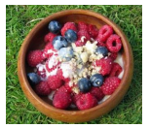  Stone age cookery – a meal fit for a caveman!  A search on google for ‘stone age recipe’ comes up with lots of interesting ideas, stone age stew, bread, oatcakes and berry pudding. Have a go at making a stone age meal and writing out the recipe for our classroom homework display.  Remember that you must NEVER eat wild berries unless supervised by and adult and that some of the recipes contain NUTS. | What would you take to the stone age?  If you went back in time to the stone age what one piece of modern technology would you bring to show people from the past and why? Write me and explanation of what you would bring to show people from over 10,000 years ago. What questions might they ask you about it? How could you use the item to help people? | 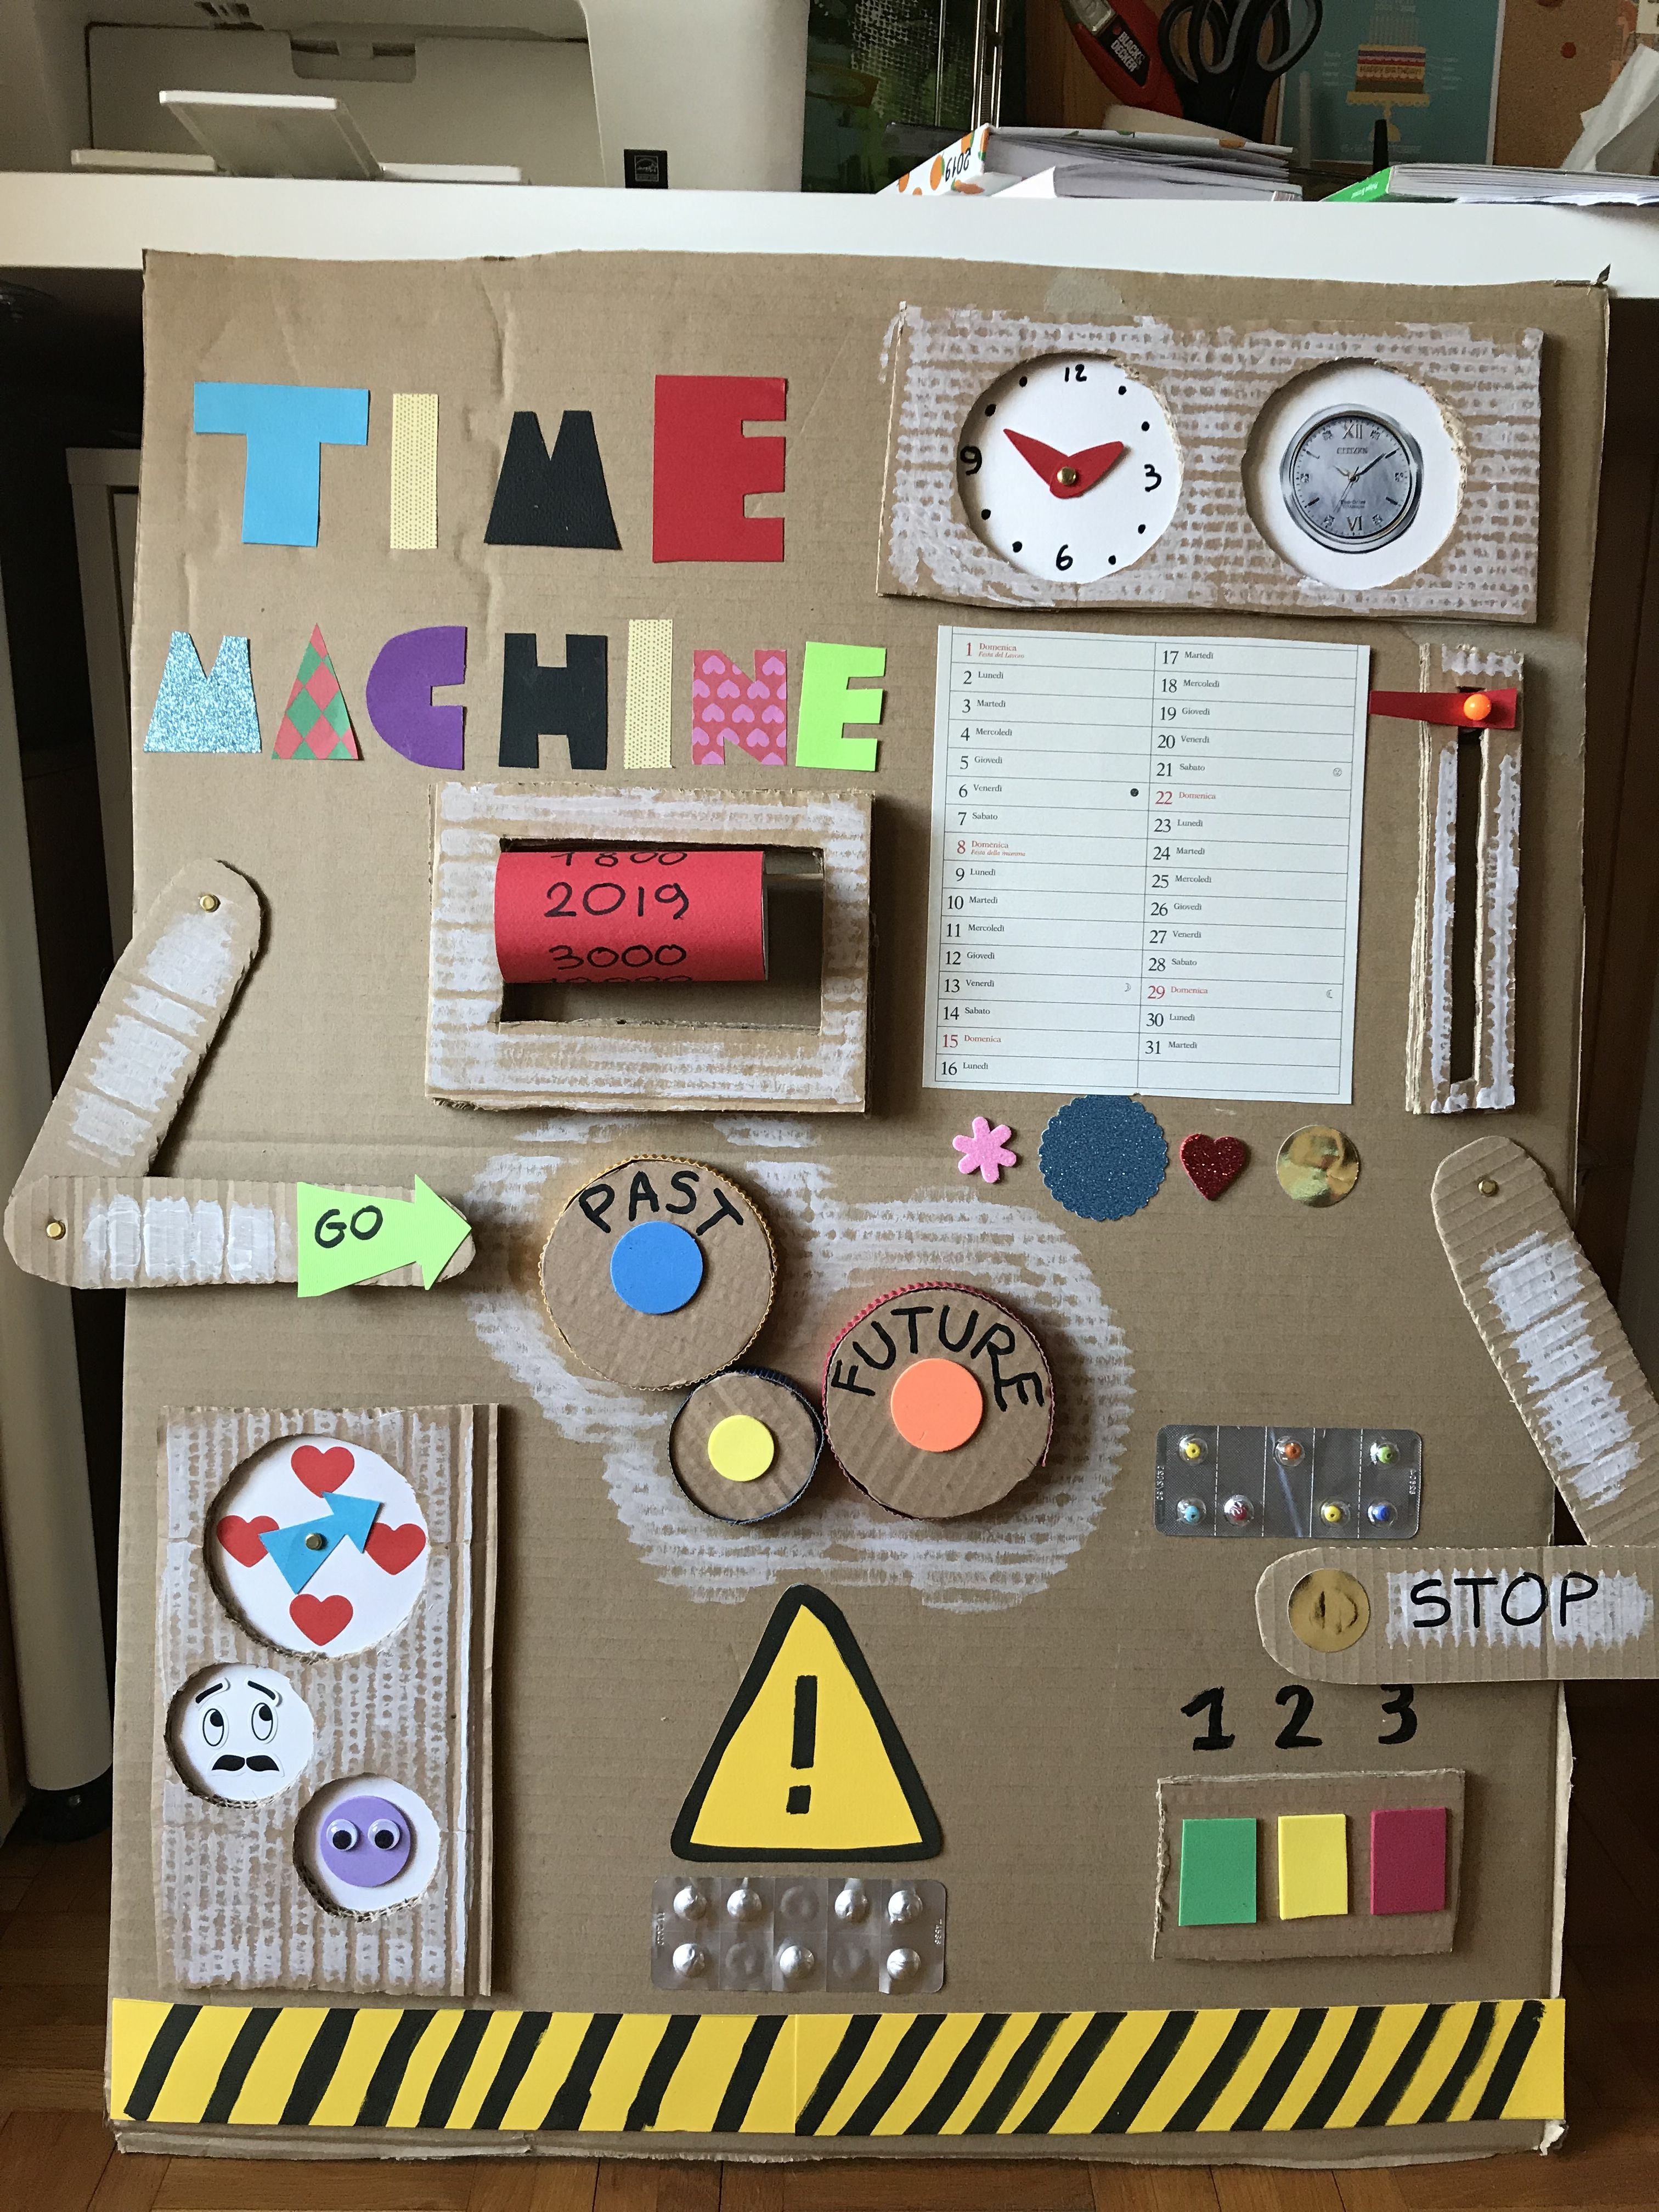  Build your own time machine  Our class text for this term is Tilly and the time machine. Can you build your own version of a time machine at home? You could use cardboard boxes, lego, recycling. You could even use electronics to make your time machine flash of make a noise.  Challenge: can you write a short story about travelling in your time machine. Where will you go?
 | Comment | Comment | Comment | Comment
Mathletics | The school has decided to continue to subscribe to mathleticsand we also now have Times Table Rockstars.  Certificates awarded on Mathletics or Rockstars this term and Karate Bands achieved:
 | Comment

