Wild Water | Launch  Two days of hands on experiences with fresh sea food and live shellfish explained by a Cornish fisherman (Jessica’s Dad). | Class Book  The Story of Grace Darling  The Sandhorse my Michael Forman  The Mousehole Cat by Antonia Barber | End Authentic Outcome  Film screened at Heartlands Film Room
What will the classroom look like?  A lighthouse home-corner in the middle of the classroom will be surrounded by fishing paraphernalia – nets, buoys, and an anchor as well as a life size dinghy in our reading corner. Children can relax in their lifejackets while looking up at a net full of fish on the ceiling and our friendly (ish) shark gazing down at them. | Developing the classroom  The children will be involved in innovating the look of their classroom throughout the project.  Each child will decorate their fish and on it record a question about the topic – something they want to learn. We will review these questions during the term as we address them.  The children will populate the topic displays with their learning on Cornish shipwrecks and their writing around our class book, The Sand Horse by Cornish writer, Michael Foreman. | Trips/visits to support project  - Trip to the National Maritime Museum in Falmouth to take part in their ‘Wreck and Rescue’ workshop.  - Trip to Lizard lighthouse to see the workings of a real lighthouse and learn about life in a manned lighthouse.  - Trips to our outdoor learning centres, particularly Godrevy beach. | Literacy genres  • Information texts  - Recounts  • Diary entries  • Newspaper reports  • Fiction stories  • Poetry
 |  | Use of outdoor class  - Godrevy beach- beach art linked to the story of The Sand Horse. Study of the Lighthouse at Godrevy.  - Crenvor Grove to bring discovery maths outdoors  - School grounds- all subjects to involve outdoor learning in the school grounds as much as possible this term, including core subjects – phonics and maths. | Innovative use of ICT  We will be using Fizzbooks to word process newspaper reports and using iPads to make videos and record our work.
Class 2 Medium term Plan Summer 2018

MINI PROJECT
Cornish Sea shanties
MINI PROJECT
Study the work of artist Lamorna Penrose
MINI PROJECT
Weather and the seasons
MINI PROJECT
Cornish shipwrecks

END OUTCOME
LAUNCH

Final Outcome- The children are going to make a film throughout the topic to share with parents and carers. The film will be shared at an exciting nearby venue.

MINI OUTCOME
Children will produce a piece of art inspired by the Cornish artist.
Children will also have the opportunity to work with materials to create their own piece of work inspired by the sea.
MINI OUTCOME
Children will make a anemometer and a rain gauge to measure our Cornish weather.

MINI OUTCOME
Listen to and perform our own sea shanties.

MINI OUTCOME
Film documentary explaining Cornish ship wrecks.

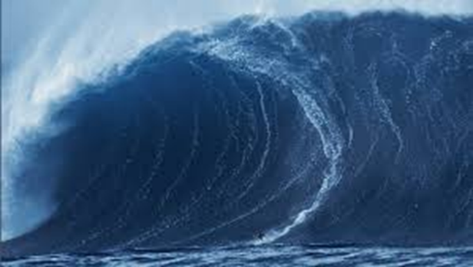
History
5 Cornish shipwrecks; HMS Ansun, SS Alba, Bencoolen, RMS Mulheim, Penlee lifeboat disaster.
Life in a lighthouse

English
Phonics – ongoing
Recount story based on Grace Darling
Quest story based on The Sandhorse and The Mousehole Cat
Information texts, newspaper reports and e-mails
Wild Water!
Art/ Design and Technology
Lamorna Penrose artist – visit to school and private view. Interview in school. Make our own paintings in similar style.
DT Felting inspired by Lamorna Penrose waterscapes.

PSHE
Footprints | What’s It Worth?
Spaceship Earth | Why do we have money?
Energy saving | Creative enterprise
Where my food comes from | Spending and saving
Developed and developing | Inequality and distribution of wealth
Biodiversity | Why some people work for free
How I can make a difference | What can I do? Fair trade.

Science
Weather and the changing seasons
Make an anemometer to measure windspeed.
Design and make a rain gauge.
Design experiments to measure sun light and temperature.
Maths (data handling) through science.

Geography
Know 5 continents and oceans
Study simple coastal formations made by the sea
Tsunamis – cause and consequence

Music
Cornish sea shanties – listen to the music of Cornish shanty singers. Learn and perform shanties together.

ICT
Word processing - ongoing
Use of iPads to create video clips
iMovie to create Wild Water film for outcomes

