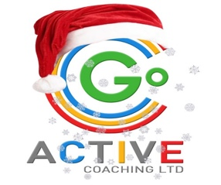
CAMBORNE AND SURROUNDING AREAS
CHRISTMAS HOLIDAY CLUB

Go Active Cornwall run holiday clubs with a difference for children aged 5 - 14 years old. We have the biggest range of sports and activities in the UK – activities that include Street Surfing, Bubble Football, Archery, Crossbows and many more!
We would like to offer you a special discount!
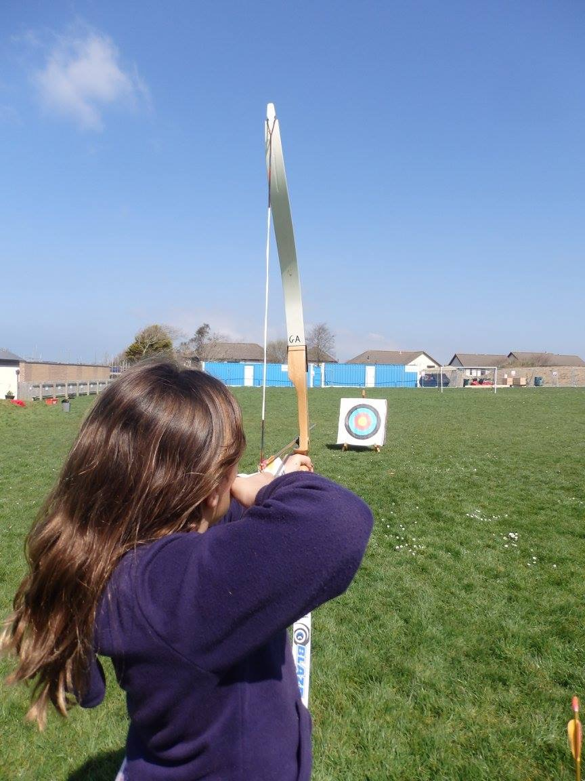
Location | Trevithick Learning Academy, Camborne
Timings | 8.30 – 16.30 (£12)
What to Bring | Suitable clothing for sports, trainers, spare clothes. Packed Lunch, Morning Snack, Plenty of water.
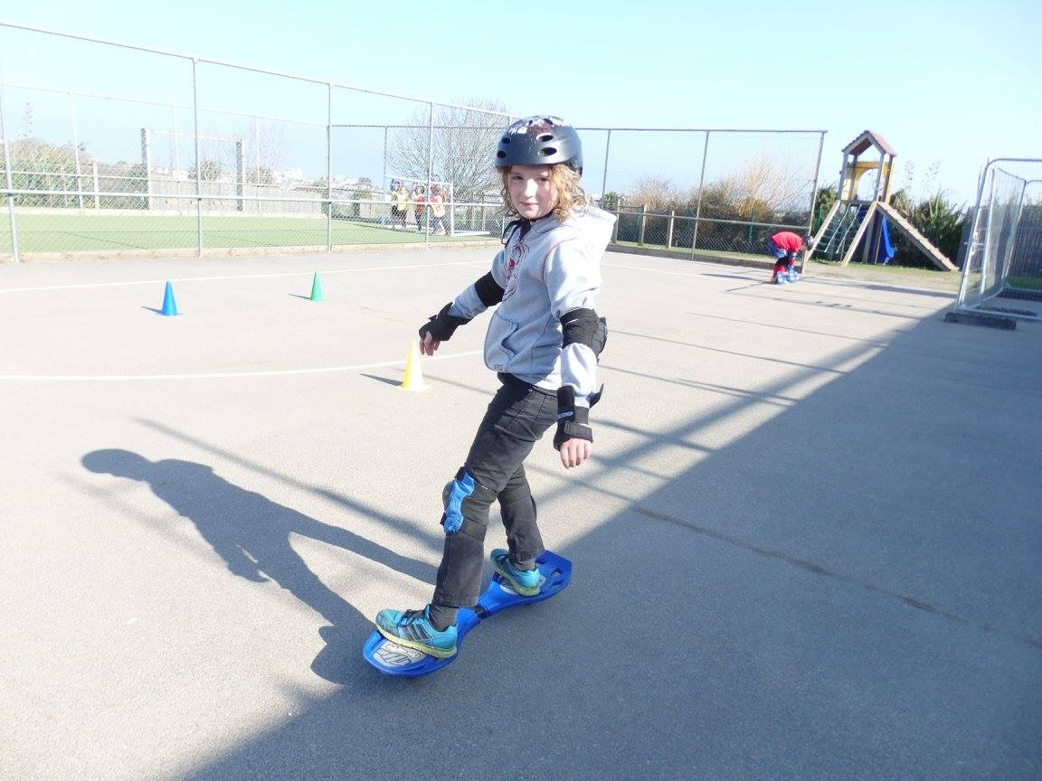
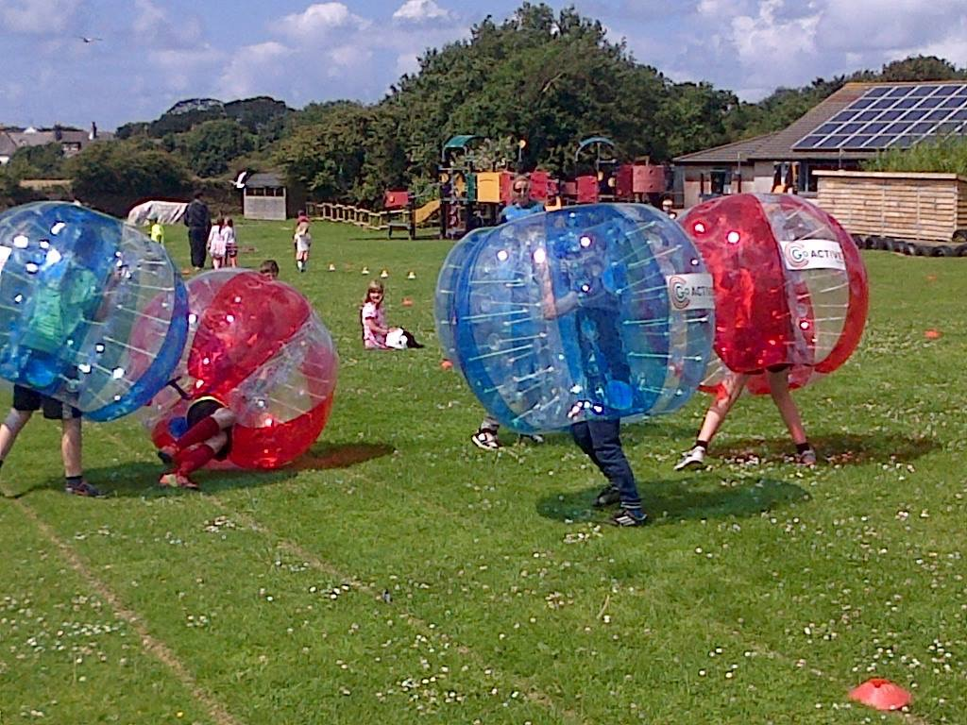
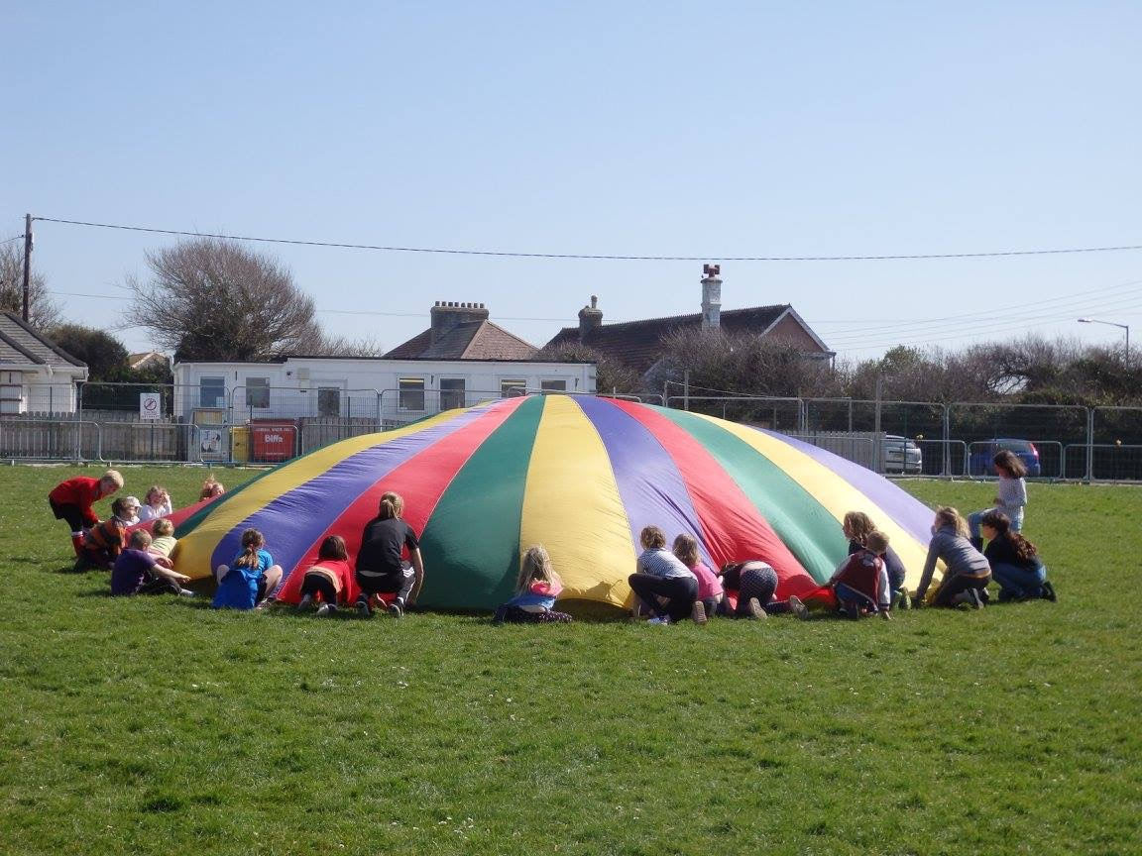
Please complete the form below by circling a time option for each day you would like your child to attend before returning it to the school office, with payment (Cash or Cheque), by no later than Friday 15th December2017. Please make Cheques Payable to 'Go Active'

Venue | Date. | 8.30 – 16.30
Trevithick Learning Academy | Friday 22nd December | £12
Trevithick Learning Academy | Wednesday 3rd January | £12
 |  | Total = £

Child’s Name ..................................................................... DOB..................... Age.............. M/F ...............
Medical Information……………………...............................................................................................................
Parent/Carer’s Name....................................................................................................................................
Parent/Carer’s Email (required, please write clearly)...................................................................................
Emergency Contact Number……………………………………….. Password for Collection ………………………………….
By signing this form I agree to Go Active Cornwall Ltd’s Terms & Conditions and Policies as stated on www.go-active.org., authorise coaching staff to administer or approve any medical treatment deemed necessary. I agree that continual disruption to the learning of others by an individual may result in removal from the course. I also consent to Go Active Cornwall Ltd taking & using photographs for promotional purposes only which include my child/children participating in Go Active coaching sessions.

Signed: Parent/Guardian……………………………………………………………………………………………

