Myths and Magic 2023

Was King Arthur real or just a legend? | Launch  Tintagel Castle – re-enacting the story of the Legend of King Arthur outdoors at the castle in costumes. Visiting Merlin’s cave. Meeting the statue of ancient king Gallos. Being inspired by the history-rich castle! | Class Books  The legends of King Arthur – Tracey Mayhew  The Lion, the Witch and the Wardrobe – C.S Lewis  Daily guided reading sessions will focus on a variety of fiction, non-fiction and poetry texts. | End Authentic Outcome  Arthurian style Christmas market in the school hall showing our amazing artistic creations! We will also display our shadow puppet theatres and movie trailers.
What will the classroom look like?  Knights of the round table with shields painted by children.  Tintagel Castle.  Merlin’s cave.  Sword in the stone made by children.  Giant opening wardrobe with Narnia scene  Tapestries hanging from ceiling  Stained glass windows in Arthurian style |  | Trips/visits to support project  - Tintagel Castle  - St Michael’s Mount to learn giant’s story  - Visiting storyteller.  - Falmouth Art Gallery King Arthur Exhibition  - Shadow puppet show and workshop. | Literacy genres  - Fiction – retelling of the Legend of King Arthur.  - Playscripts – Shadow puppet plays  - Poetry – spells inspired by Macbeth witches.  - Setting description – a wizard’s shop  - Non-Chronological report – Dragons
 |  | Use of outdoor class  - Re-enacting myths in Crenver Grove  - Fire cooking on Godrevy beach to inspire witches poetry.  - Exploring shadows outdoors  - Potion making in the woods  - Quest for the holy Grail orienteering | Innovative use of ICT  - Using Imovie to create and edit movie trailers adding music and using text to create subtitles. Research  - Use of programmes to present information texts (word and publisher)

MINI OUTCOME – Art – printing
Printing a Shield
The children will learn how to make a multi-layer foam block print to create a shield inspired by King Arthur’s knights of Camelot. These will be used to decorate our Arthurian market stalls.

LAUNCH

MINI OUTCOME – Cooking – Design Technology
Magical treats and sweets
Children will learn about reversible and irreversible changes while creating some edible treats fit for a wizard!

MINI OUTCOME – poems
Witches spell poetry
Inspired by the witches from Macbeth the children will write their own gruesome potion poetry to be presented at the outcome in a ‘potions spell book’.

MINI OUTCOME – Computing
Movie trailer
Children will use imovie to film and edit a ‘movie trailer’ for their shadow puppet shows. These will be presented at our Arthurian market outcome.
MINI OUTCOME – Science and Design Technology
Shadow Puppet
Children will design and make shadow puppets of wizards, knights and dragons and write their own playscripts and design sets. They will perform a shadow puppet play to younger children.

MINI OUTCOME – Art
Tapestries
Inspired by the storytelling tapestries from history, the children will design and make their own colourful woven Arthurian tapestry.
Arthurian style Christmas Market
END OUTCOME

Physical Education: first half term= TBA second half term= TBA
Going for Goals | What’s it worth
Believing it’s possible | Why do we have money?
Setting a realistic goal | Creative Enterprise
Planning to reach a goal | Spending and Saving
Overcoming barriers | Inequality and distribution of wealth
Persistence | Why some people work for free.
Celebrating | What can I do? Fair Trade.
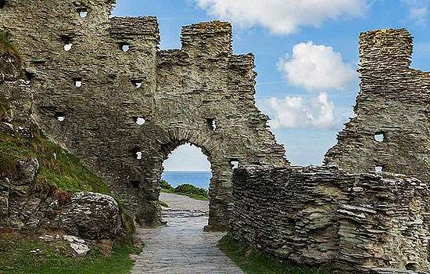
Computing/ICT
- Explore the use of video to film edit and present movie trailers for our shadow puppet shows.
- Explore how multimedia can create atmosphere & appeal to different audiences.

Local History
- Understand the methods of historical enquiry, including how it is used to make historical claims. (Was King Arthur real or just a legend?)

Art
We will learn how to use weaving and sewing techniques to create tapestries inspired by the tales of King Arthur.
We will learn how to create a 2-layer print.

Design Technology
- Design and make a moving shadow puppet, joining and combining materials with fixed or moving parts.
- use research and develop design criteria to inform the design of innovative, functional, appealing products that are fit for purpose, aimed at particular individuals or groups.

Science
Light and shadows
- recognise that they need light in order to see things and that dark is the absence of light
- notice that light is reflected from surfaces
- recognise that light from the sun can be dangerous and that there are ways to protect their eyes
- recognise that shadows are formed when the light from a light source is blocked by a solid object
- find patterns in the way that the size of shadows change.

Main TOPIC
Myths and Magic

